**Peak Potential Announces Digital Platform to Empower Individuals to Maintain Consistent Fitness Routines**

Peak Potential: A fitness and nutrition platform empowering 16-24-year-olds to build consistency and discipline, creating lifelong healthy habits in a fun and accessible way.

**Chicago, IL – Tuesday, January 21st, 2025**

CHICAGO - Peak Potential is revolutionizing fitness with a comprehensive platform that empowers individuals to achieve their health and wellness goals without overwhelming their daily lives. Designed for 16-24-year-olds, it combines personalized fitness and nutrition plans, advanced analytics, professional coaching, and vibrant community features. Whether you’re a beginner or someone with gym experience struggling to maintain consistency, Peak Potential provides tailored resources and expert guidance to foster physical, mental, and emotional resilience. Launching today, Peak Potential’s app/website offers tailored resources and expert guidance to make fitness a sustainable and enjoyable lifestyle, helping users balance the demands of school, work, and life while improving overall well-being.

With a busy academic lifestyle, thousands of students struggle to maintain consistent fitness and nutrition routines due to the following challenges:

1. Lack of Time: Many people often struggle to maintain a solid fitness and diet plan with their busy schedules, leading to a lack of consistency.
2. Difficulty Tracking Progress: Logging workouts and tracking fitness metrics can feel tedious and time-consuming, leading to disengagement.
3. Unbalanced Routines: Many individuals want to stay healthy without allowing fitness to dominate their lives, but they struggle to strike that balance.

Peak Potential addresses these challenges by offering:

1. Consistency Without Overwhelm: Tailored plans ensure users can achieve their fitness goals with manageable routines that fit their unique schedules, whether they prefer gym or at-home workouts.
2. Effortless Progress Tracking: Fun and easy-to-use tracking tools help users monitor their fitness journey without the hassle of tedious data logging. Visual results and insights keep users motivated and engaged.
3. Customized Dieting Plans: Nutrition plans tailored to the user’s lifestyle and profession (e.g., a salesperson vs. a teacher) ensure diets are realistic and sustainable while meeting their fitness goals.
4. Accountability and Community Support: A vibrant in-app community connects users with like-minded individuals who offer encouragement, accountability, and shared motivation.

The company seeks to help and empower young adults like never before. “At Peak Potential, we understand that staying consistent with fitness is one of the hardest parts of maintaining a healthy lifestyle. Many people feel overwhelmed by the time commitment and effort involved, but they still want to be healthy and see results. Our goal is to simplify fitness, make it accessible, and help people create sustainable routines they can actually stick to without letting it take over their lives. Fitness should enhance your life, not dominate it,” said Avi Bedi, Co-founder and CEO of Peak Potential.

Getting started with Peak Potential is simple and seamless. First, users visit www.peakpotential.com or download the mobile app from the App Store or Google Play. Next, users complete a short questionnaire about your fitness goals, lifestyle, and preferences. Finally, users will gain instant access to their personalized fitness, nutrition plan, progress tracking tools, and a supportive community to keep you motivated.

The early user launch (beta testing) had phenomenal reactions and validated the demand for Peak Potential. “As someone who’s always struggled to stick to a consistent workout routine, Peak Potential has been a game-changer. The tailored plans fit perfectly into my busy schedule, and I love how easy it is to track my progress without spending hours logging everything. I’ve finally found a way to stay healthy while balancing school and work!” – Emily Carter, Beta User.

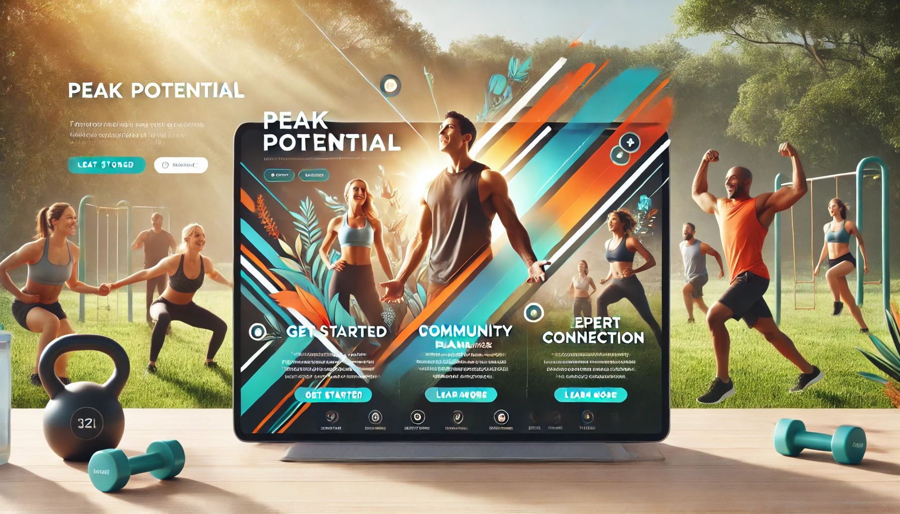

Discover how Peak Potential can transform your health and wellness journey today. Visit peakpotential.com or download the mobile app to sign up and start unlocking your full potential. Join the vibrant community and take the first step toward a healthier, happier you!

### **FAQs for Peak Potential**

1. **Q:** How does Peak Potential create personalized fitness plans?  
   **A:** Peak Potential’s platform uses data-driven insights to design fitness and nutrition plans tailored to your unique goals, fitness level, schedule, workout environment, and budget. By tracking your progress, Peak Potential continuously optimizes your plan to ensure you stay on track and achieve measurable results.
2. **Q:** What makes Peak Potential different from other fitness platforms?  
   **A:** Unlike other platforms, Peak Potential integrates fitness, nutrition, mental well-being, and fitness guidance into a single, comprehensive ecosystem. With advanced analytics and a vibrant community, Peak Potential redefines fitness as a lifestyle, not just a goal.
3. **Q:** How does Peak Potential ensure affordability?  
   **A:** Peak Potential understands that fitness can be expensive. Peak Potential offers budgeting tools to help you manage costs related to gym memberships, equipment, healthy meals, and supplements, ensuring fitness remains accessible to everyone.
4. **Q:** Is Peak Potential suitable for beginners?  
   **A:** Yes, Peak Potential caters to all fitness levels. Peak Potential’s personalized plans and instructional videos ensure beginners can start safely and effectively while building confidence and knowledge.
5. **Q:** How do I get started with Peak Potential?  
   **A:** Getting started is easy! Simply sign up on our website or app, set your fitness goals, and complete a quick questionnaire about your preferences and needs. From there, your personalized plan will be ready, and you’ll gain access to all the features Peak Potential has to offer.
6. **Q:** Is there a free trial for Peak Potential?  
   **A:** Yes, Peak Potential offers a free trial so you can experience our features and benefits firsthand. After the trial, you can choose a plan that best fits your needs and goals.